Week 12-1:

--User-defined function – Recursive function

ROLL NO.:241501059

Name: Gowtham M

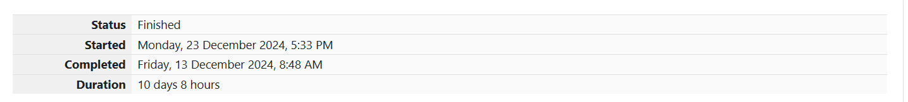

**Q1)** A binary number is a combination of 1s and 0s. Its nth least significant digit is the nth digit

starting from the right starting with 1. Given a decimal number, convert it to binary and

determine the value of the the 4th least significant digit.

**Example**

number = 23

• Convert the decimal number 23 to binary number: 2310 = 24 + 22 + 21 + 20 =

(10111)2.

• The value of the 4th index from the right in the binary representation is 0.

Function Description

Complete the function fourthBit in the editor below.

fourthBit has the following parameter(s):

int number: a decimal integer

Returns:

int: an integer 0 or 1 matching the 4th least significant digit in the binary

representation of number.

**Constraints**

0 ≤ number < 231

**Input Format for Custom Testing**

Input from stdin will be processed as follows and passed to the function.

The only line contains an integer, number.

**Sample Input**

STDIN Function

----- --------

32 → number = 32

**Sample Output**

0

**Explanation**

• Convert the decimal number 32 to binary number: 3210 = (100000)2.

• The value of the 4th index from the right in the binary representation is 0.

OUTPUT:

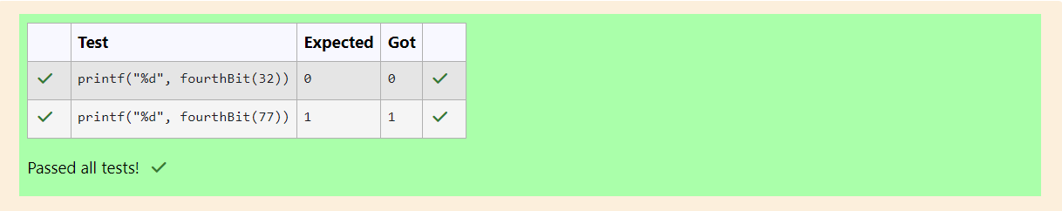

**Q2)** Determine the factors of a number (i.e., all positive integer values that evenly divide into

a number) and then return the pth element of the list, sorted ascending. If there is no pth

element, return 0.

Example

n = 20

p = 3

The factors of 20 in ascending order are {1, 2, 4, 5, 10, 20}. Using 1-based indexing, if p =

3, then 4 is returned. If p > 6, 0 would be returned.

Function Description

Complete the function pthFactor in the editor below.

pthFactor has the following parameter(s):

int n: the integer whose factors are to be found

int p: the index of the factor to be returned

Returns:

int: the long integer value of the pth integer factor of n or, if there is no factor at that

index, then 0 is returned

**Constraints**

1 ≤ n ≤ 1015

1 ≤ p ≤ 109

**Input Format for Custom Testing**

Input from stdin will be processed as follows and passed to the function.

The first line contains an integer n, the number to factor.

The second line contains an integer p, the 1-based index of the factor to return.

**Sample Input**

STDIN Function

----- --------

10 → n = 10

3 → p = 3

**Sample Output**

5

**Explanation**

Factoring n = 10 results in {1, 2, 5, 10}. Return the p = 3rd factor, 5, as the answer.

OUTPUT:

